summary of Detecting Malicious URLs using lexical analysis

Abstract:

In this paper, authors explore an approach to detection and categorization of the malicious URLs according to their attack type. It turns out lexical analysis is effective, on the other hand, the effect of the obfuscation techniques on malicious URL is rare.

**Lexical Analysis**

1. data collection: 114400URLs in four categories: spam, malware, phishing, defacement

2. feature selection: CFSSubsetEval, Infogain as feature selection algorithms

Initially 79 features were selected, after applying feature selection algorithms, different sets of features have been chosen for different categories of data.

3. classification: KNN, C4.5, Random

the results of lexical analysis on single-class datasets, the accuracy of the all datasets with selected set of features are higher than 97 %. For multiclass dataset, the average of accuracy is more than 95%.

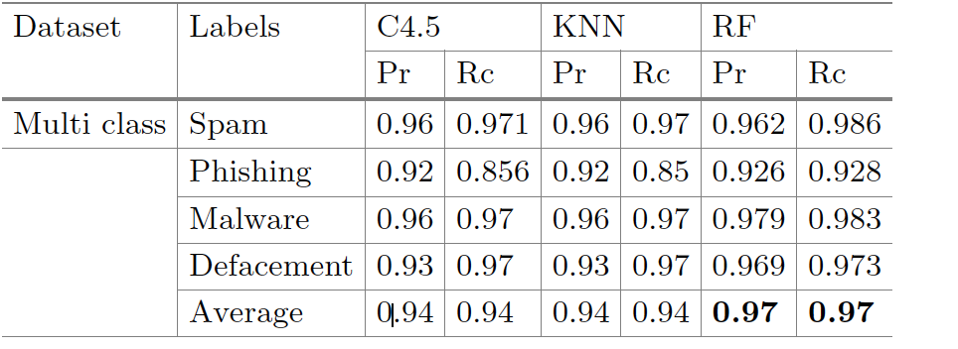

4. result:

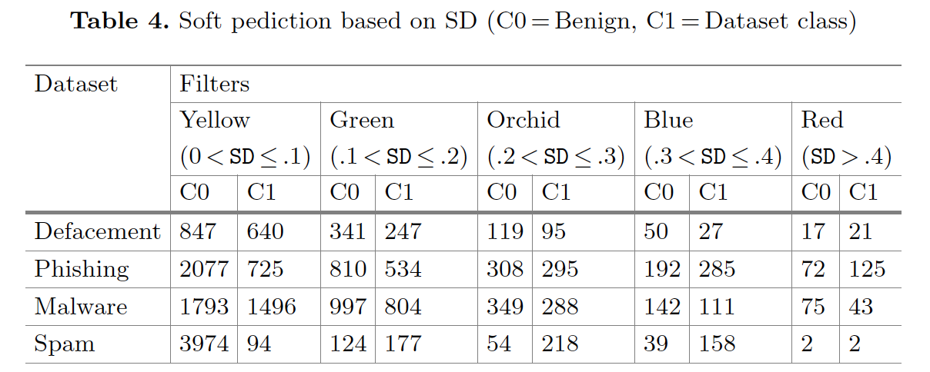

soft prediction is represented by a Standard Deviation

If the soft prediction is closer to 1 with a small threshold value of SD, the URL is risky. In the opposite way, the closer the URL is to 0 with a small SD score, the more secure it is.

Random Forest yields highest accuracy among the classifiers tested.

Mean decrease accuracy mean decrease gini

Random forest computes how much each variable contributing to the accuracy of the model.

**Obfuscation techniques:**

no significant output has been noticed for obfuscation type AuthString and Hex for any of datasets.

conclusion:

Despite random forest classification accuracy is able to identify approx. 97% of the malicious or benign URL, by using proper SD filter we could reach up to around 99% accuracy.